import os

from mistralai import Mistral

from dotenv import load_dotenv

from qdrant_client.models import PointStruct

from qdrant_client.models import Distance, VectorParams

from qdrant_client import QdrantClient

Import required

load_dotenv()

qdrant_client = QdrantClient(":memory:")

Loading environment variables and setting up qdrant location

api_key = os.getenv("MISTRALAI_API_KEY")

client = Mistral(api_key=api_key)

Initializing api setup for mistral

def generate_context(url):

model = "pixtral-12b-2409"

messages = [

{

"role": "user",

"content": [

{

"type": "text",

"text": "Extract the text from the image precisely, extract every text."

},

{

"type": "image_url",

"image_url": url

}

]

}

]

*# Get the chat response*

chat_response = client.chat.complete(

model=model,

messages=messages

)

*# return the context*

return chat_response.choices[0].message.content

Generate context from the given image using **pixtral-12b-2409** model. Context will then be used to feed into the Qdrant database.

**Context Generated** :

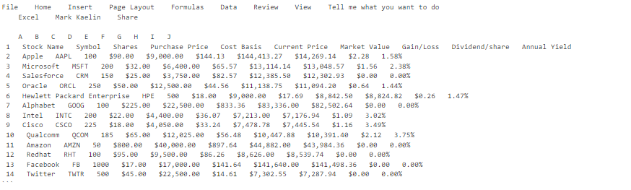

def embed(context, model = "mistral-embed"):

embeddings_batch_response = client.embeddings.create(

model=model,

inputs= context

)

return embeddings_batch_response

Used to generate embeddings and return the batch of embeddings.

def generate_embeddings(context: str):

model = "mistral-embed"

context = context.split('\n')

data = []

client = Mistral(api_key=api_key)

embeddings_batch_response = embed(context, model)

for i in range(len(embeddings_batch_response.data)):

temp = []

temp.append(context[i])

temp.append(embeddings_batch_response.data[i].embedding)

data.append(temp)

return data

Prepare the embedding the the required format of list of [raw_context, embeddings]

def initialize_qdrant(length: int):

vector_size = length

*# Define the vectors configuration*

vector_params = VectorParams(

size=vector_size, *# Size of the vectors*

distance=Distance.COSINE *# Choose distance metric (COSINE, EUCLID, or IP)*

)

*# Create the collection with the specified configuration*

if "CHATBOT" not in qdrant_client.get_collections().collections[0].name:

qdrant_client.create_collection(

collection_name="CHATBOT",

vectors_config=vector_params *# Specify vector configuration*

)

Initialise the Qdrant collection for continuous use, collection used is “CHATBOT”.

def qdrant_entry(final_data):

points=[PointStruct( id=i, vector=final_data[i][1],payload={'raw_context':final_data[i][0] }) for i in range(len(final_data))]

qdrant_client.upsert(collection_name="CHATBOT", points=points)

print(qdrant_client.get_collections())

Enter the context and final_data earlier derived in Qdrant database in form of Points.

def query_qdrant(query, collection_name='CHATBOT', limit=4):

query_vector=embed([query]).data[0].embedding

result = qdrant_client.search(

collection_name = collection_name,

query_vector=query_vector,

limit = limit,

with_vectors = False

)

*# search_result=[]*

return result

Query from Qdrant database the top 4 relevant element in the database with a given query,

Firstly convert the query into embedding and then push the same in query_quadrant usecase.

def prepare_llm_context(result):

*# result[0].payload['raw_context']*

context =[]

for i in range(len(result)):

context.append(result[i].payload['raw_context'])

return context

From the response of query_qdrant use it to form a context which will then be provided to mistral text responder.

if __name__ == "__main__":

choice = input("Enter 'query' for rag query \n 'entry' for rag entry")

if choice == 'entry':

url: str = "https://assets.techrepublic.com/uploads/2017/04/aexcelpowerbi.png"

context = generate_context(url)

final_data = generate_embeddings(context)

*# final_data[1][1]--->size*

initialize_qdrant(len(final_data[0][1]))

qdrant_entry(final_data)

else:

query = input("Enter the query : ")

result = query_qdrant(query)

context = prepare_llm_context(result)

response = query_llm(context, query)

Main control of the program, use it according to need of entry of more data or make a query over the existing data, change of url is required as per the entry changes.

Output :

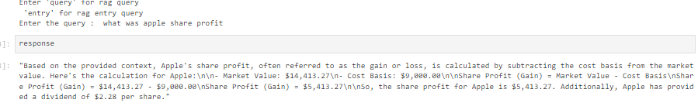

**Bill 1** :

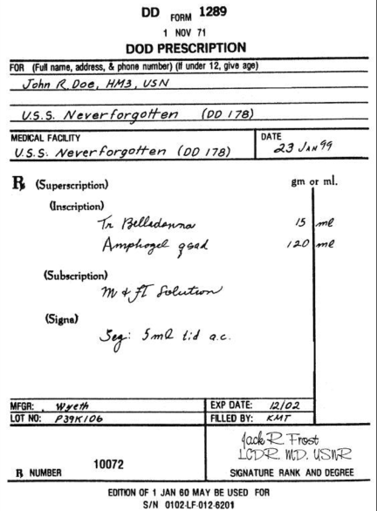

**Output :**

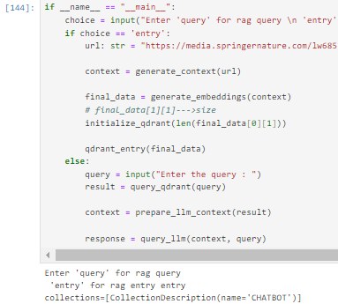

Parsed bill :

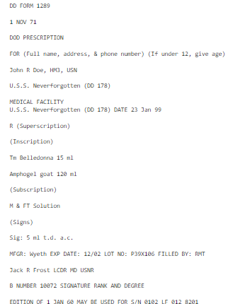

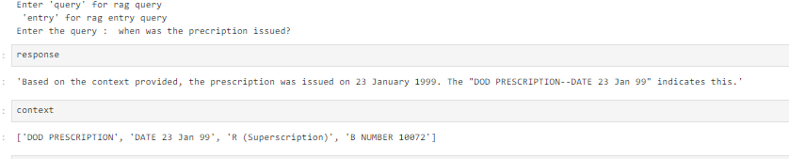

'Based on the context provided, the prescription was issued on 23 January 1999. The "DOD PRESCRIPTION--DATE 23 Jan 99" indicates this.'

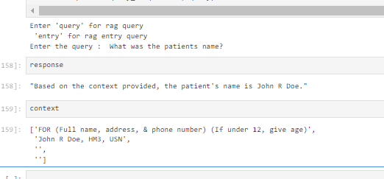

**Bill 2 :**

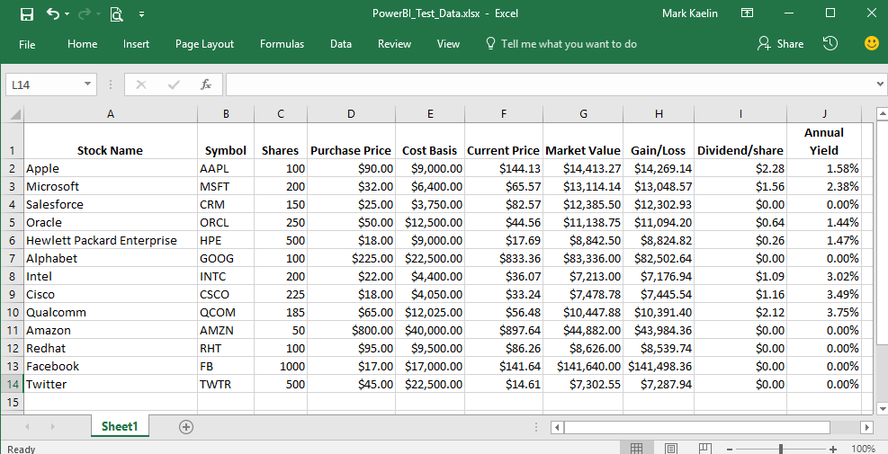

**Entry Outputs:**

